CLASS zcl_3930_flight DEFINITION
PUBLIC
CREATE PUBLIC .

PUBLIC SECTION.
DATA :
carrier_Id TYPE /dmo/carrier_id READ-ONLY,
connection_Id TYPE /dmo/connection_id READ-ONLY,
airport_from TYPE /DMO/AIRPORT_from_ID READ-ONLY,
airport_to TYPE /DMO/AIRPORT_to_ID READ-ONLY.

METHODS : constructor
IMPORTING !carrier_id TYPE /dmo/carrier_id
!connection_id TYPE /dmo/connection_id
!plane_type TYPE /dmo/plane_type_id
RAISING
zcx_c_abapd_no_connection.

PROTECTED SECTION.
DATA : plane_type TYPE /dmo/plane_type_id.

PRIVATE SECTION.

ENDCLASS.

CLASS zcl_3930_flight IMPLEMENTATION.

METHOD constructor.
me->carrier_id = carrier_id.
me->connection_id = connection_id.
me->plane_type = plane_type.

SELECT SINGLE airport_from_id, airport_to_id
FROM /dmo/connection
WHERE carrier_id = @carrier_id AND connection_id = @connection_id
INTO ( @me->airport_from, @me->airport_to ).
IF sy-subrc <> 0.
RAISE EXCEPTION TYPE zcx_c_abapd_no_connection.
ENDIF.

ENDMETHOD.

ENDCLASS.

CLASS zcl_3930_passenger_flight DEFINITION
PUBLIC
INHERITING FROM zcl_3902_flight
CREATE PUBLIC .

PUBLIC SECTION.
METHODS constructor
IMPORTING
carrier_id TYPE /dmo/carrier_id
connection_id TYPE /dmo/connection_id
plane_type TYPE /dmo/plane_type_id
RAISING
zcx_c_abapd_no_connection.

PROTECTED SECTION.
PRIVATE SECTION.
DATA : seats_max TYPE /dmo/plane_seats_max.

ENDCLASS.

CLASS zcl_3930_passenger_flight IMPLEMENTATION.
METHOD constructor.

super->constructor( carrier_id = carrier_id connection_id = connection_id plane_type = plane_type ).
SELECT SINGLE MaximumSeats FROM zi_cabapd_passenger
WHERE PlaneTypeId = @plane_type
INTO @me->seats_max .
IF sy-subrc <> 0.
RAISE EXCEPTION TYPE zcx_c_abapd_no_connection.
ENDIF.

ENDMETHOD.

ENDCLASS.

CLASS zcl_3930_connections DEFINITION
PUBLIC
FINAL
CREATE PUBLIC .

PUBLIC SECTION.
METHODS get_connections
IMPORTING
i_departure TYPE /dmo/airport_from_id
RETURNING
VALUE(r_connections) TYPE zcert_connections.
PROTECTED SECTION.
PRIVATE SECTION.

ENDCLASS.

CLASS zcl_3930_connections IMPLEMENTATION.
METHOD get_connections.
SELECT
carrier_id,
airport_from_id,
airport_to_id,
'-' AS airport_via_id
FROM /dmo/connection
WHERE airport_from_id = @i_departure
UNION ALL
SELECT c1~carrier_id,
c1~airport_from_id,
c2~airport_to_id AS airport_to_id,
c1~airport_to_id AS airport_via_id
FROM /dmo/connection AS c1
INNER JOIN /dmo/connection AS c2
ON c1~carrier_id = c2~carrier_id
AND c1~airport_to_id = c2~airport_from_id
WHERE c1~airport_from_id = @i_departure
AND c2~airport_to_id <> @i_departure
INTO TABLE @r_connections.

ENDMETHOD.

ENDCLASS.

@EndUserText.label : 'Template for RAP BO Exercise 3930'
@AbapCatalog.enhancement.category : #NOT_EXTENSIBLE
@AbapCatalog.tableCategory : #TRANSPARENT
@AbapCatalog.deliveryClass : #A
@AbapCatalog.dataMaintenance : #RESTRICTED
define table zz3930travel {

key client : abap.clnt not null;
key travel_uuid : sysuuid_x16 not null;
agency_id : /dmo/agency_id;
travel_id : /dmo/travel_id;
description : /dmo/description;
start_date : /dmo/begin_date;
end_date : /dmo/end_date;
status : /dmo/travel_status;
created_at : abp_creation_tstmpl;
created_by : abp_creation_user;
last_changed_at : abp_lastchange_tstmpl;
last_changed_by : abp_lastchange_user;
local_last_changed_at : abp_locinst_lastchange_tstmpl;

}
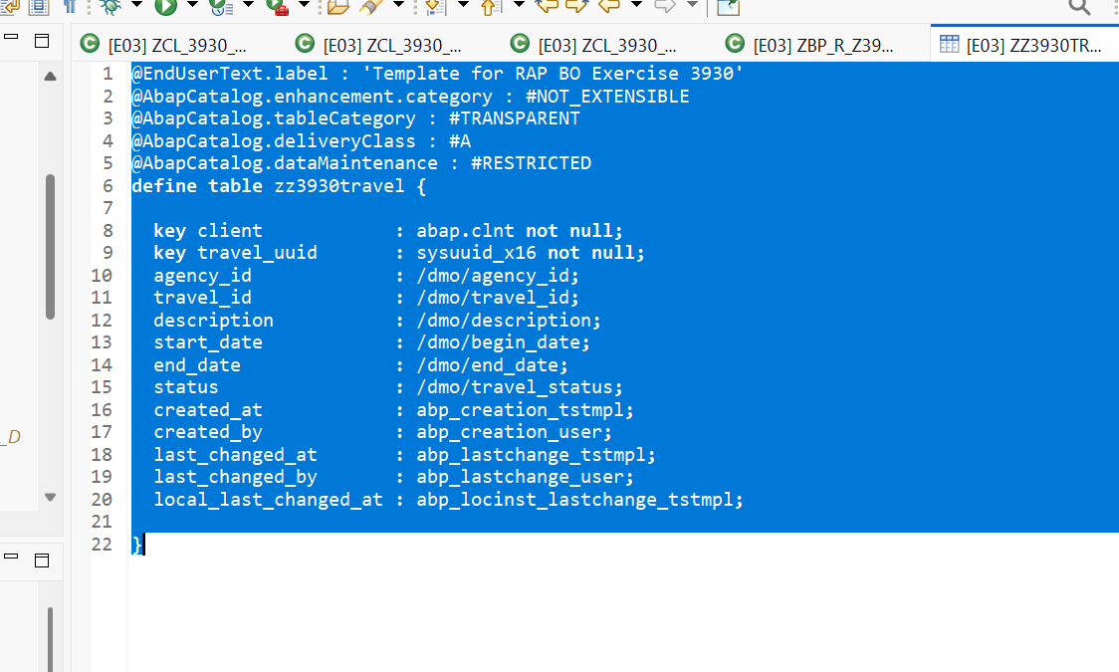
For step 2 of task 6
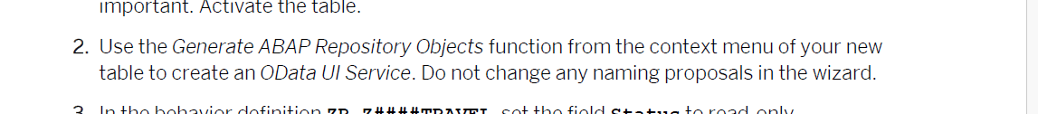

Follow this
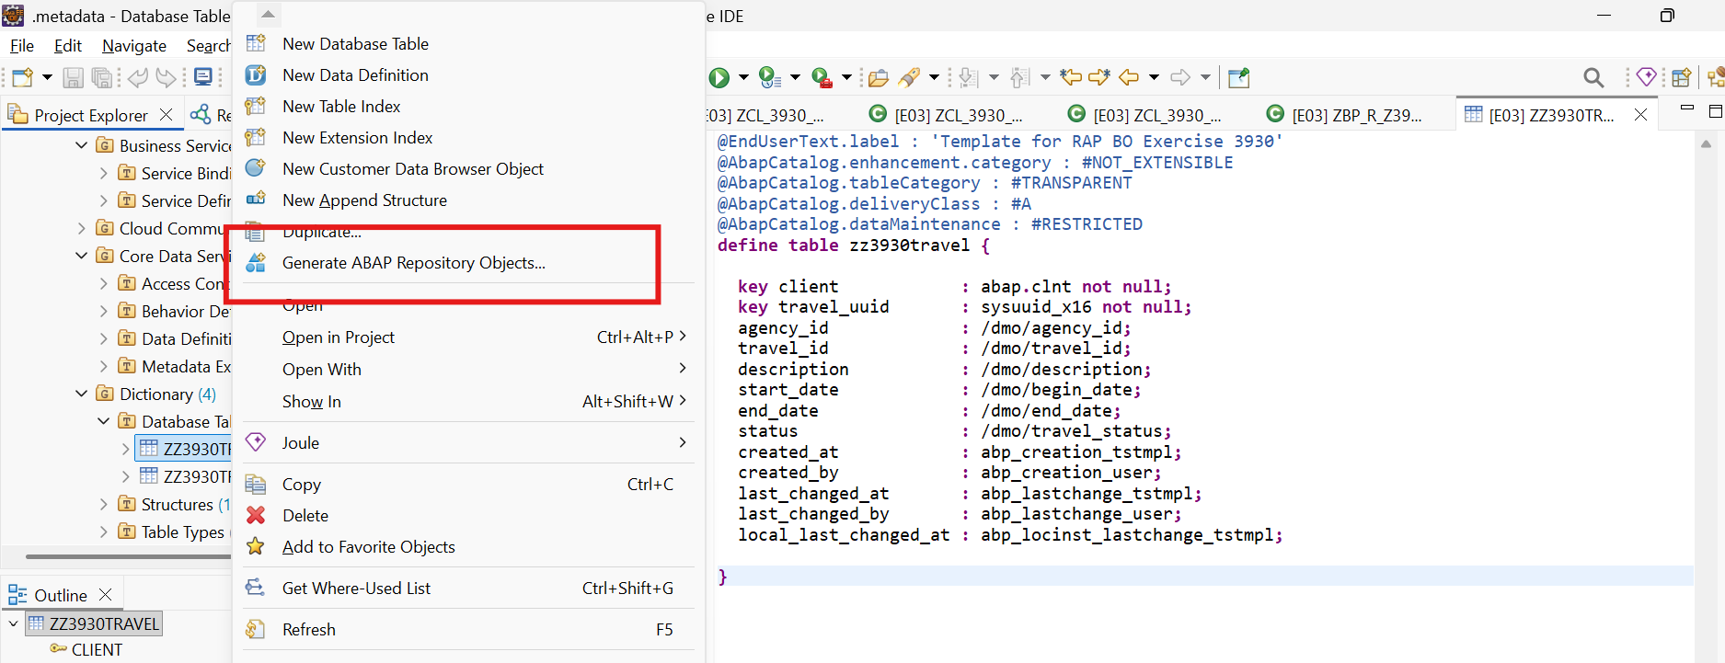

Right click on the table created . Select generate abap repository objects
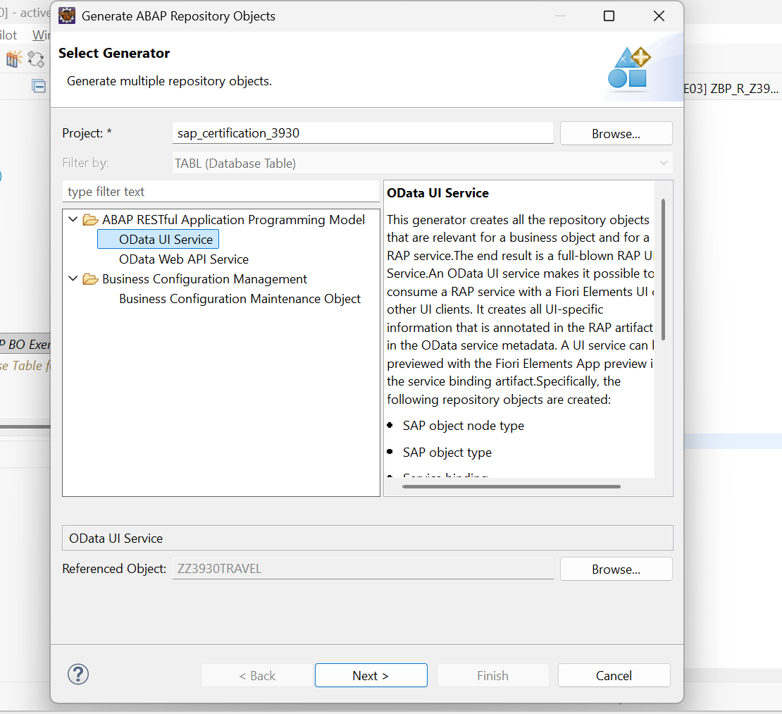
Select OData UI service . Click next
enter package
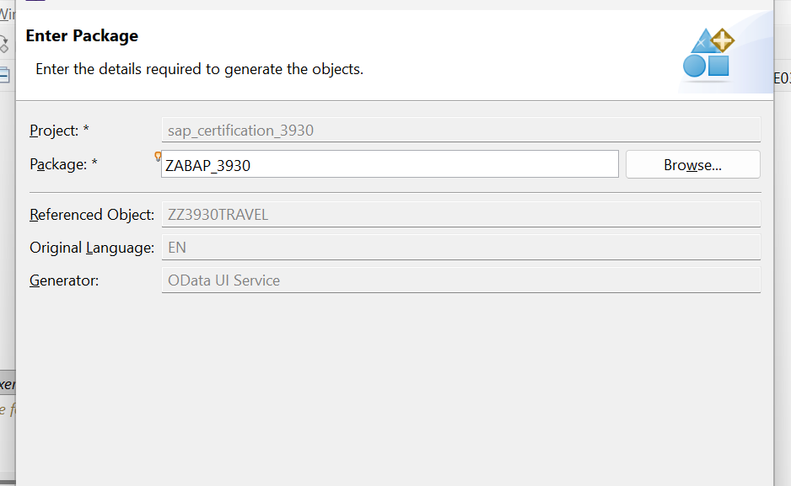

After that again select Next
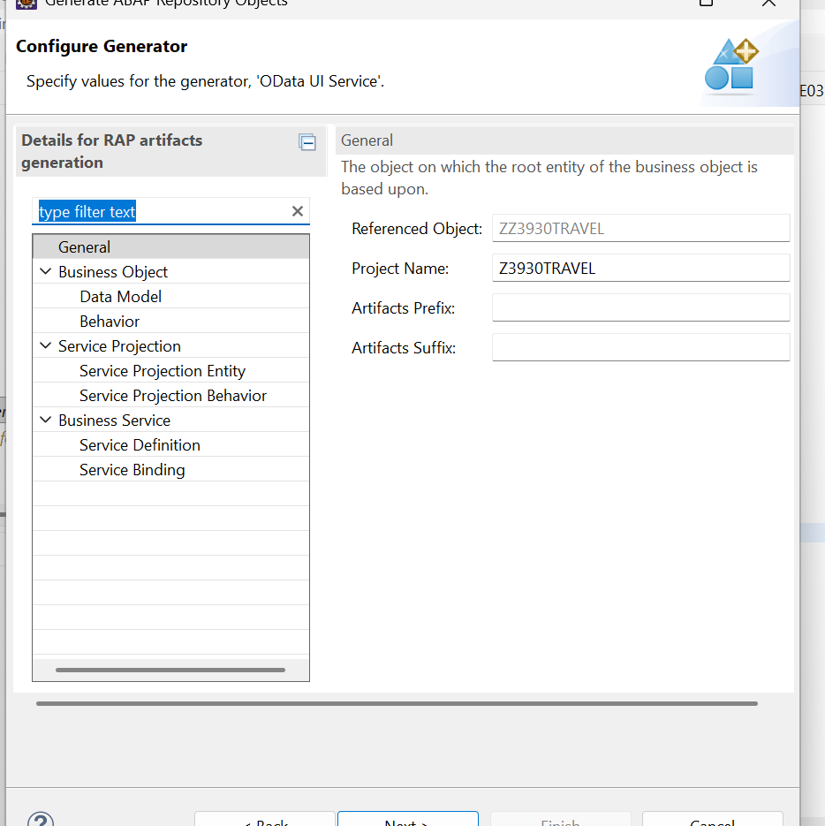

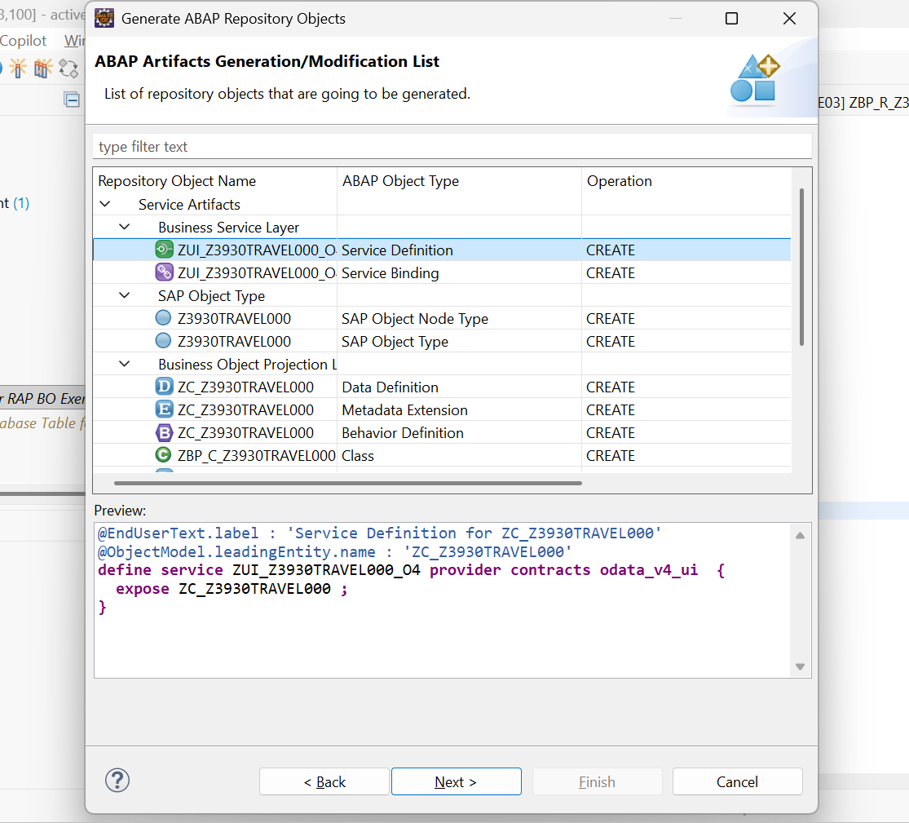

Select Next and Finish . after all objects are created Publish it and then Preview.

Task 7:
In Behaviour Definition of the following
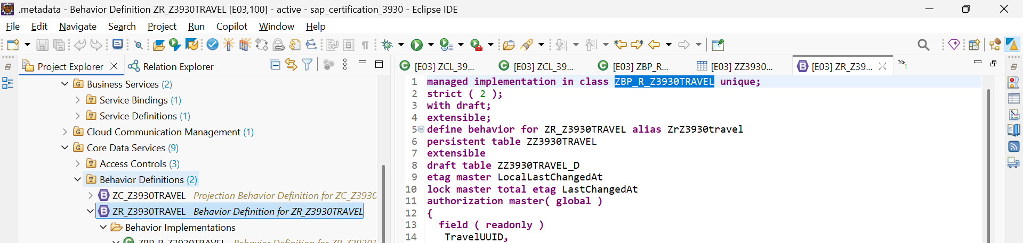
add new field Status
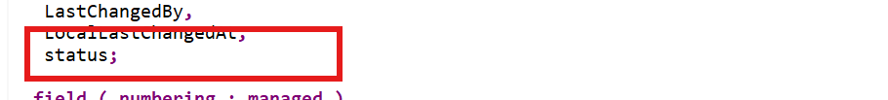

And
add one more line after draft determine action Prepare
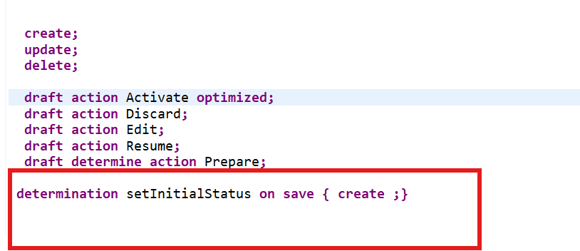

determination setInitialStatus on save { create ;}

Next step : Implement the setInitialStatus by clicking on the suggestion (bulb: add method definition)
then go the implementation class lhc_zr_z3930travel

And under the method setInitialStatus write the following code
METHOD setInitialStatus.
READ ENTITIES OF zr_z3930travel IN LOCAL MODE
ENTITY ZrZ3930travel
FIELDS ( Status )
WITH CORRESPONDING #( keys )
RESULT DATA(lt_travel).

MODIFY ENTITIES OF zr_z3930travel IN LOCAL MODE
ENTITY ZrZ3930travel
UPDATE
FIELDS ( Status )
WITH VALUE #( FOR travel IN lt_travel ( %tky = travel-%tky
status = 'N' ) )
FAILED DATA(failed).

ENDMETHOD.
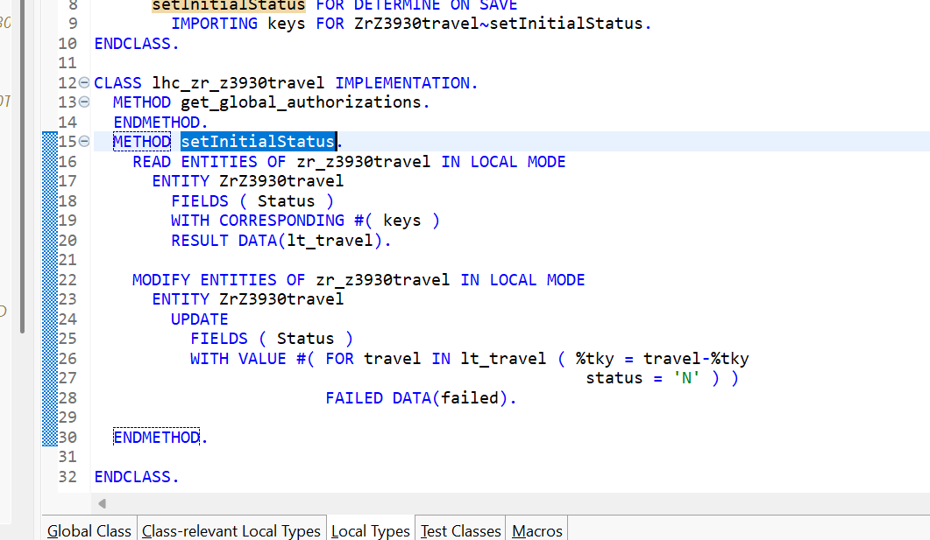

Save and activate .

Task 7:
Copy the cds zc_abap_d_agency and create one new cds entity z####_agency and paste it .
actiavete .
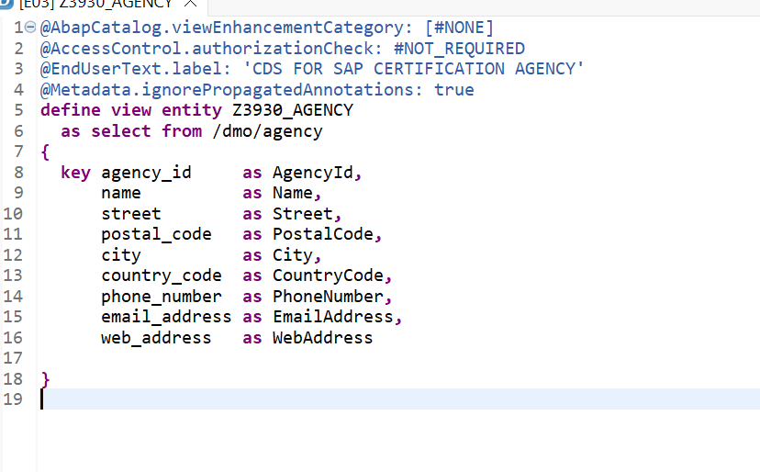
next step :after activating the cds right click on it creta access control
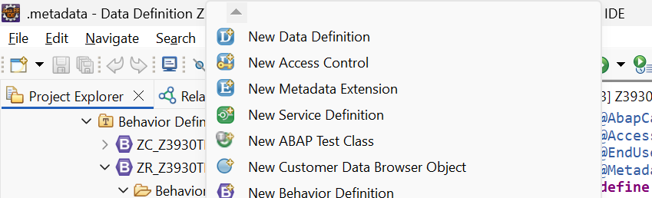

Write the where condition
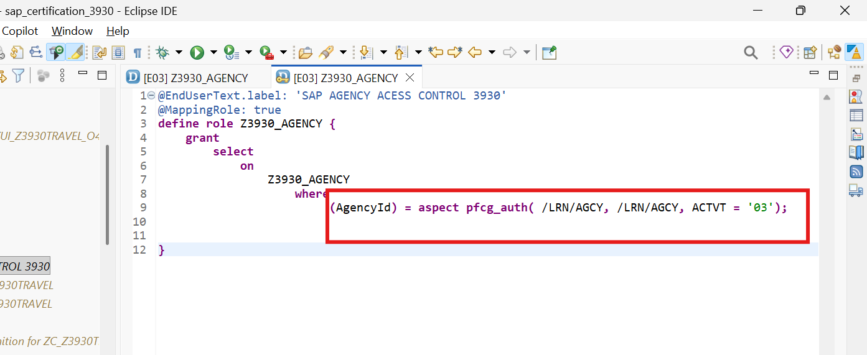

@EndUserText.label: 'SAP AGENCY ACESS CONTROL 3930'
@MappingRole: true
define role Z3930_AGENCY {
grant
select
on
Z3930_AGENCY
where
(AgencyId) = aspect pfcg_auth( /LRN/AGCY, /LRN/AGCY, ACTVT = '03');

}

Task: 8
We need create a global exception class zcx+###_no_agency.
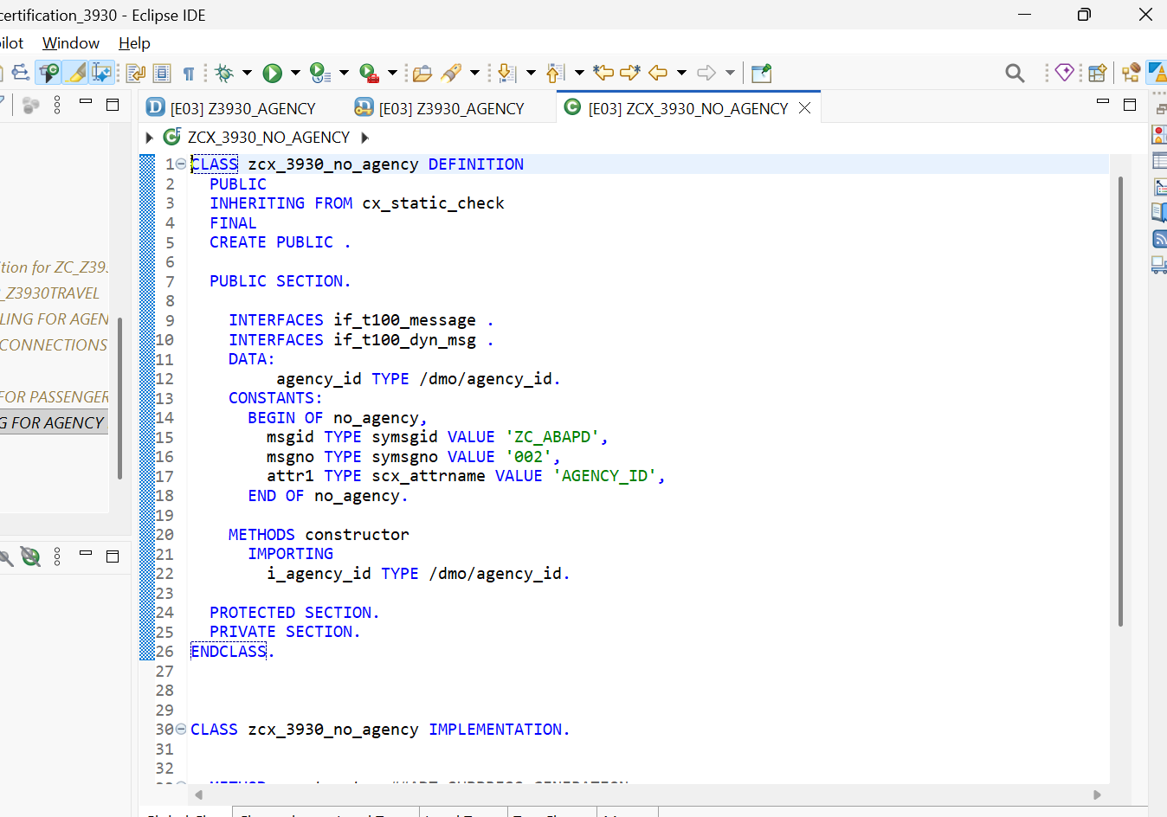

CLASS zcx_3930_no_agency DEFINITION
PUBLIC
INHERITING FROM cx_static_check
FINAL
CREATE PUBLIC .

PUBLIC SECTION.

INTERFACES if_t100_message .
INTERFACES if_t100_dyn_msg .
DATA:
agency_id TYPE /dmo/agency_id.
CONSTANTS:
BEGIN OF no_agency,
msgid TYPE symsgid VALUE 'ZC_ABAPD',
msgno TYPE symsgno VALUE '002',
attr1 TYPE scx_attrname VALUE 'AGENCY_ID',
END OF no_agency.

METHODS constructor
IMPORTING
i_agency_id TYPE /dmo/agency_id.

PROTECTED SECTION.
PRIVATE SECTION.
ENDCLASS.

CLASS zcx_3930_no_agency IMPLEMENTATION.

METHOD constructor ##ADT_SUPPRESS_GENERATION.
super->constructor( ).
me->agency_id = i_agency_id.
me->if_t100_message~t100key-msgid = no_agency-msgid.
me->if_t100_message~t100key-msgno = no_agency-msgno.
me->if_t100_message~t100key-attr1 = no_agency-attr1.

ENDMETHOD.
ENDCLASS.

Next create a global class zcl_####agency_model and copy paste the zcl_agency_model
And call the exception class if no data comes

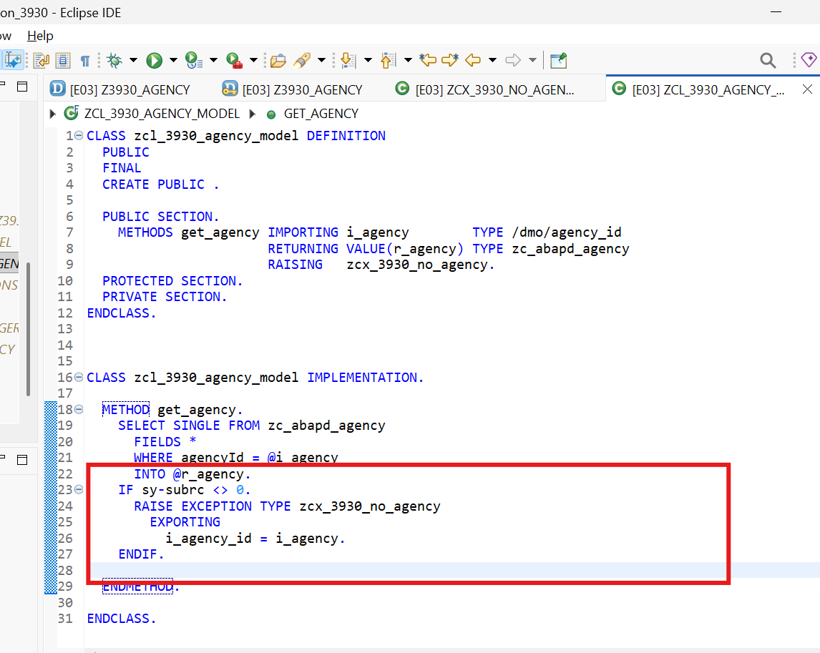

CLASS zcl_3930_agency_model DEFINITION
PUBLIC
FINAL
CREATE PUBLIC .

PUBLIC SECTION.
METHODS get_agency IMPORTING i_agency TYPE /dmo/agency_id
RETURNING VALUE(r_agency) TYPE zc_abapd_agency
RAISING zcx_3930_no_agency.
PROTECTED SECTION.
PRIVATE SECTION.
ENDCLASS.

CLASS zcl_3930_agency_model IMPLEMENTATION.

METHOD get_agency.
SELECT SINGLE FROM zc_abapd_agency
FIELDS *
WHERE agencyId = @i_agency
INTO @r_agency.
IF sy-subrc <> 0.
RAISE EXCEPTION TYPE zcx_3930_no_agency
EXPORTING
i_agency_id = i_agency.
ENDIF.

ENDMETHOD.

ENDCLASS.

Task 9:
Create a structure z####_customer
And remember to change the enhancement category to #EXTENSIBLE_CHARACTER_NUMERIC
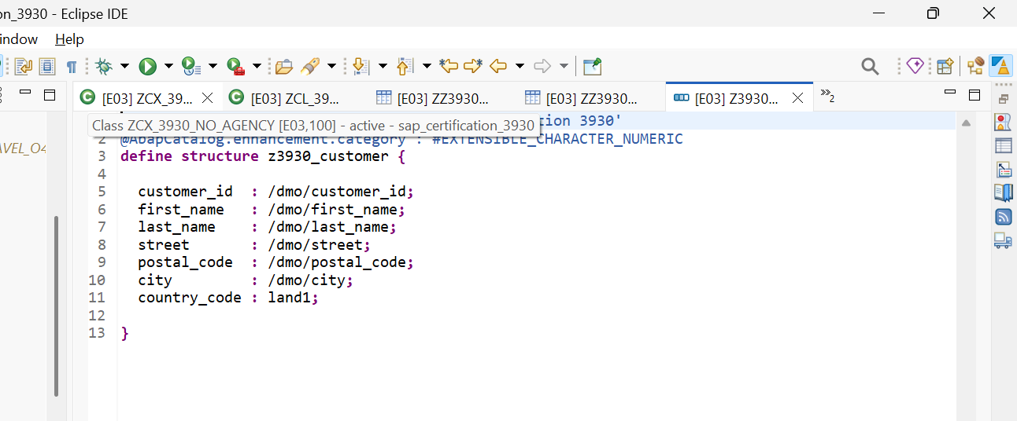
@EndUserText.label : 'Stucture for sap certification 3930'
@AbapCatalog.enhancement.category : #EXTENSIBLE_CHARACTER_NUMERIC
define structure z3930_customer {

customer_id : /dmo/customer_id;
first_name : /dmo/first_name;
last_name : /dmo/last_name;
street : /dmo/street;
postal_code : /dmo/postal_code;
city : /dmo/city;
country_code : land1;

}
Table Type:
